## Business case: Analytics to measure impacts of weekly updates on yield curves

### Context:

A prior development in SCOR’s pricing tool is the quarterly update of yield curves, which are relevant for calculation of discounted profitability measures. The official pricing results are based on economic assumptions as at pricing date.

We have a tool which is refreshing pricing results by re-simulating pricings, where economic parameters are provided as inputs. The re-simulation results are stored in a database.

Due to increased volatility in yield curves, the pricing management requested to get weekly re-simulation results of the portfolio. The re-simulation results should allow to measure the profitability of the portfolio with consistent economic assumption and identify market changes prior to the quarterly update of the parameters in the pricing tool.

Problem statement:

We want to make use of the weekly data and hence would like to get insights on how to manage the workflow, how a visualization of the weekly updates would look, and proposals of how business gains data insights by analytics on top of the standard KPI described in the objectives. Explain your ideas.

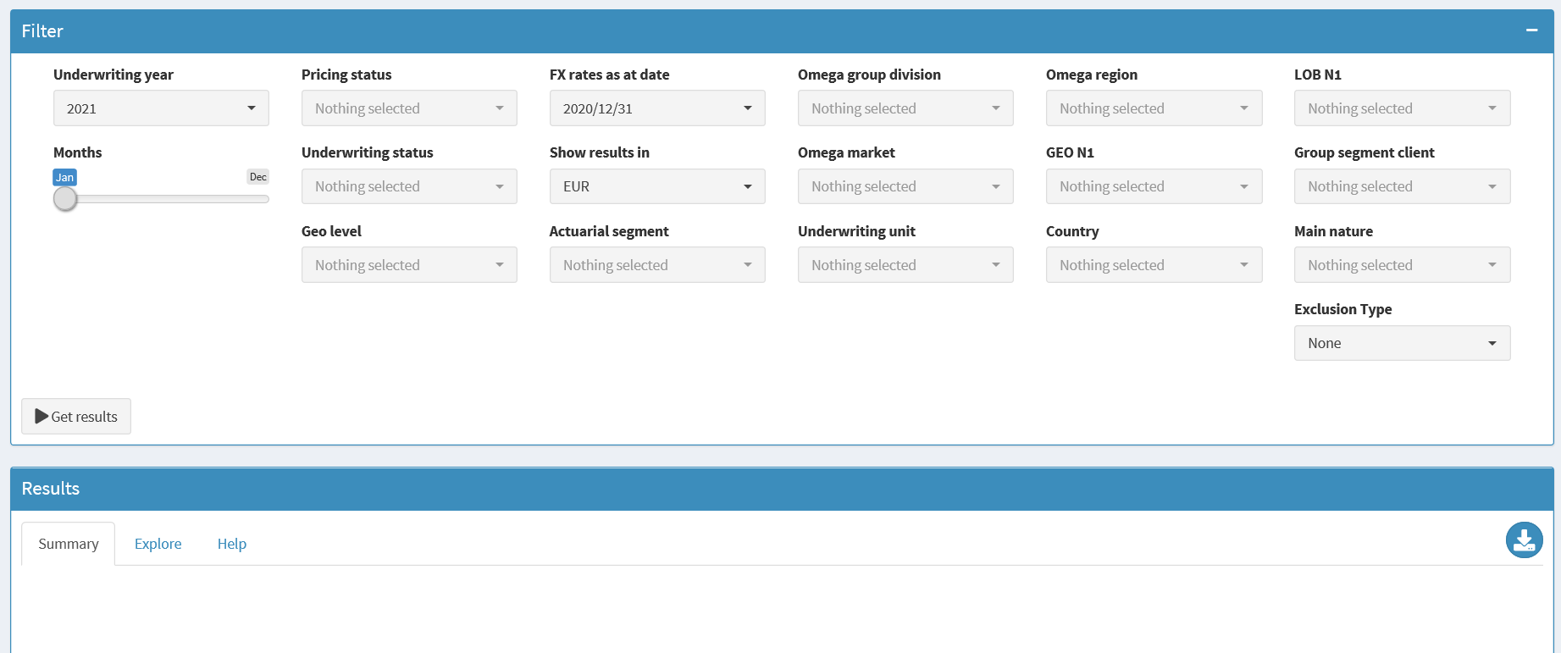

*Picture 1: Illustration of a tool with a filter screen allowing the user to filter the underlying data prior retrieving analytics by pressing the get results button.*

**Supporting data sets:**

* Export of the re-simulation results with amounts expressed in EUR our share for various re-pricing dates. Note the yield curve inputs are available in this file.



* Export of original pricing results from the pricing database (short version) with amount expressed in EUR our share using FX as at 31.10.2020.



### Objective:

1. Measure the impact on the discounted Underwriting ratio, which is defined by:
$$Discounted UWR = \frac{\left(DISCOUNTED_EXTERNAL_EXPENSES + DISCOUNTED_EXP_LOSS + EXP_PREMIUM– DISCOUNTED_EXP_PREMIUM\right)}{EXP_PREMIUM}$$

2. Suggest a visualization which allows to:
   1. Focus on major yield curves underlying the filtered business
   2. Connect the change in discounted UWR with its relevant shifts of the weekly update of yield curves.

(Please note: The user will filter in the tool for a sub-portfolio prior to getting results)

1. What logic would you suggest such that the visualization does not get overloaded by 52 trajectories per year and the small changes are still visible.
2. How will you identify trends of the changing discounted UWR.